Adding new Font files
Additional fonts are available for use on your computer and therefore in your AV sequences.  Many fonts are available at no cost, from the Internet. Two websites offering many fonts are:  www.1001freefonts.com | 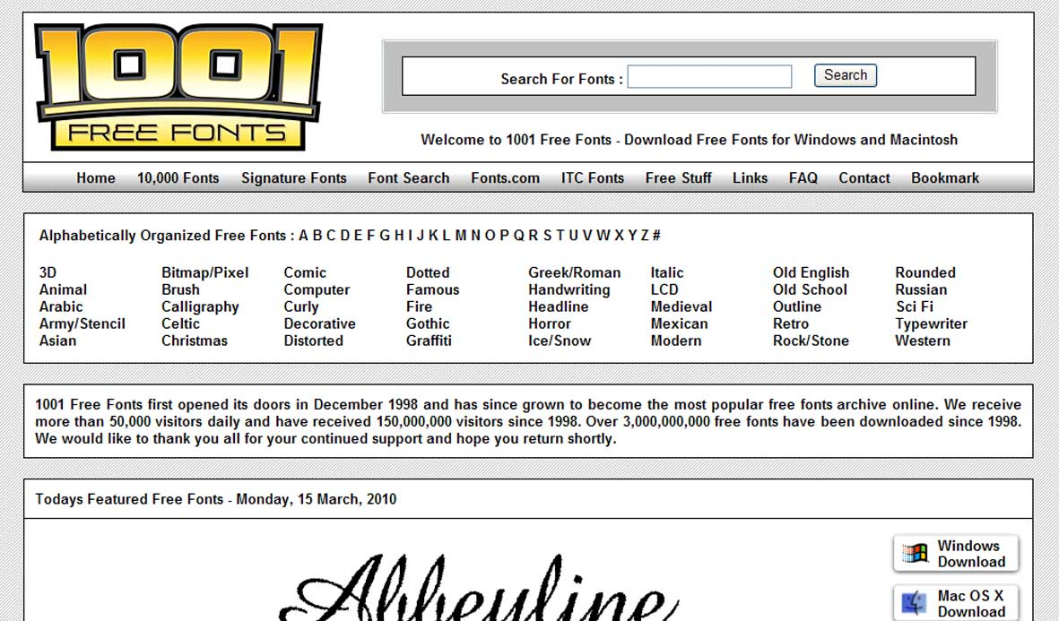
www.1001fonts.com | 
When you have found a font you like the look of, you need to download it to your computer.  Click on the appropriate ‘download’ | 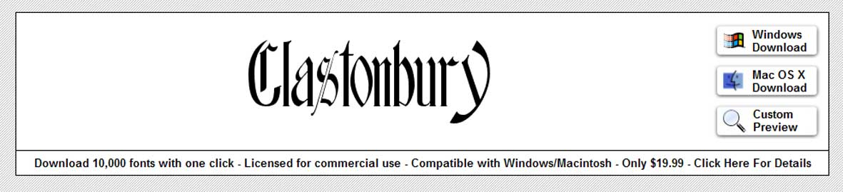
Save the file to a dedicated folder.  For example, on my PC I have created a folder in ‘My Documents’ called ‘Downloads’ and within that a folder called ‘Fonts’. | 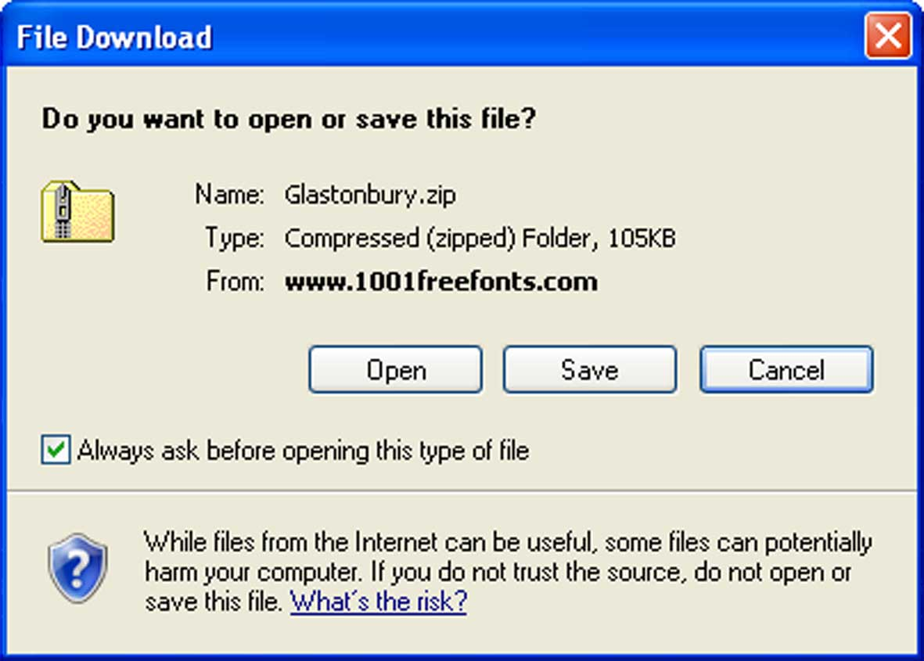  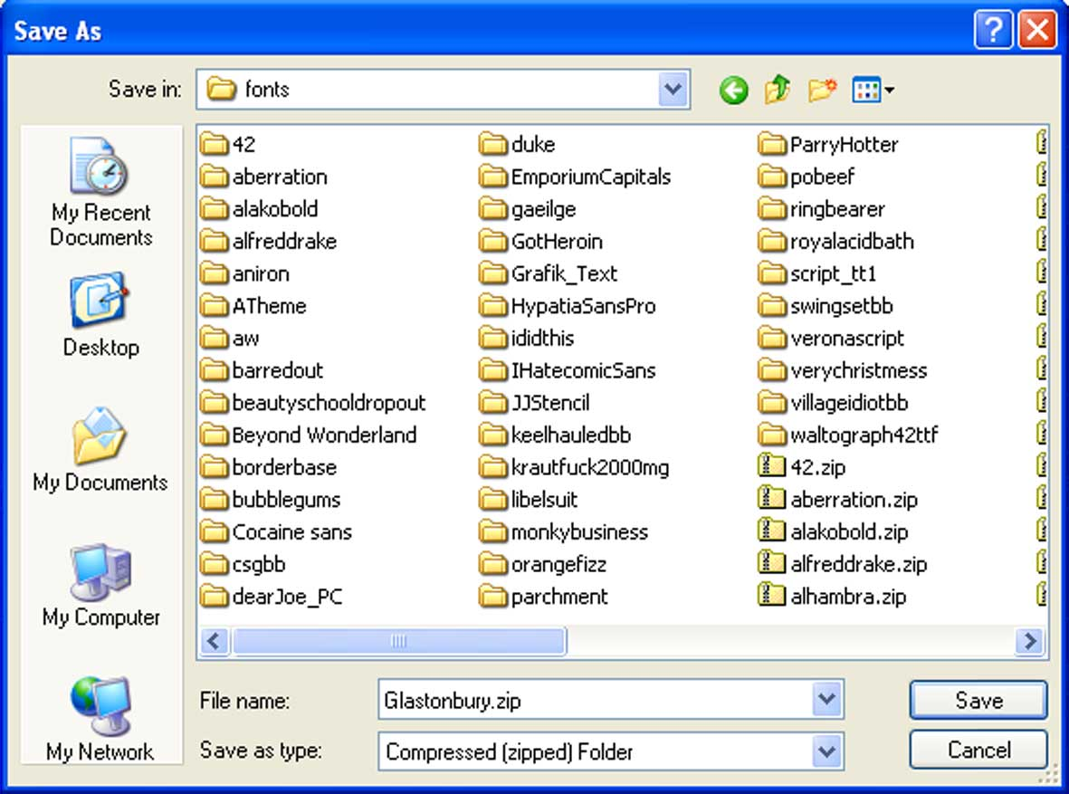
Navigate to your chosen folder
…and Save the file
The new font will have been downloaded as a Zip file. This has to be ‘un-zipped’ before you can use it.  Open the file | 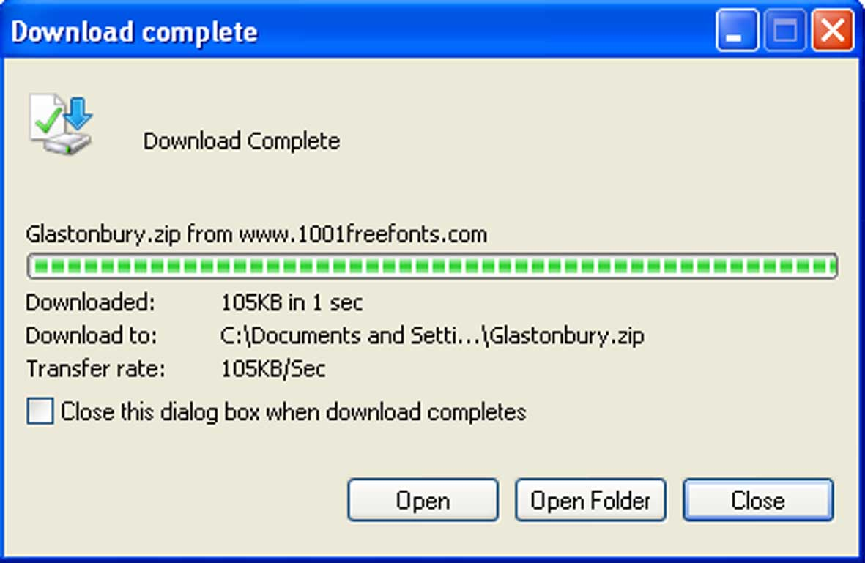  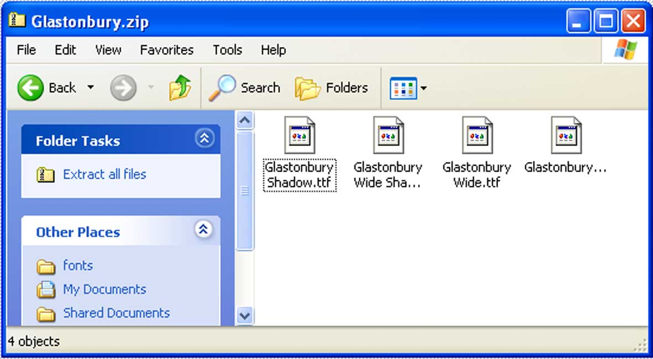
..and Extract all files
… or if you get past this stage, find the file that you have just downloaded in your chosen folder.  Right click on the folder and  … Extract all | 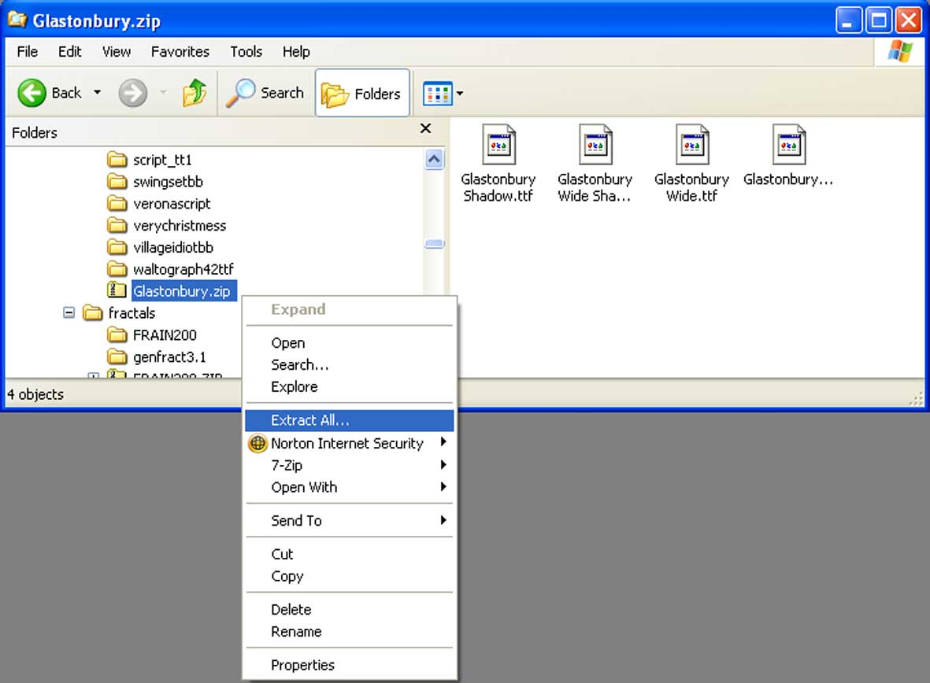
This will take you into a simple ‘Wizard’,  Unless you know better, just click  Next  Next  Finish  And you will get a new folder in the same directory folder, containing the unzipped files | 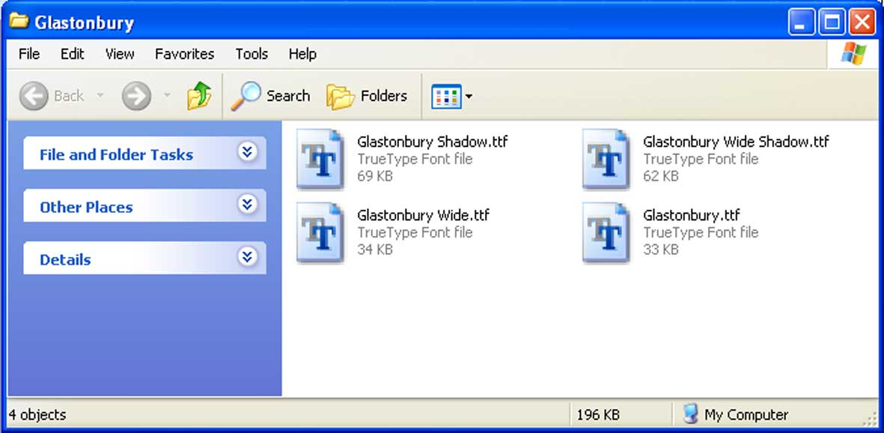
The font files are now downloaded, unzipped and on your computer. However the computer now needs to be told to use these new fonts.  Open the control panel  ..by clicking on the start button and then on Control Panel | 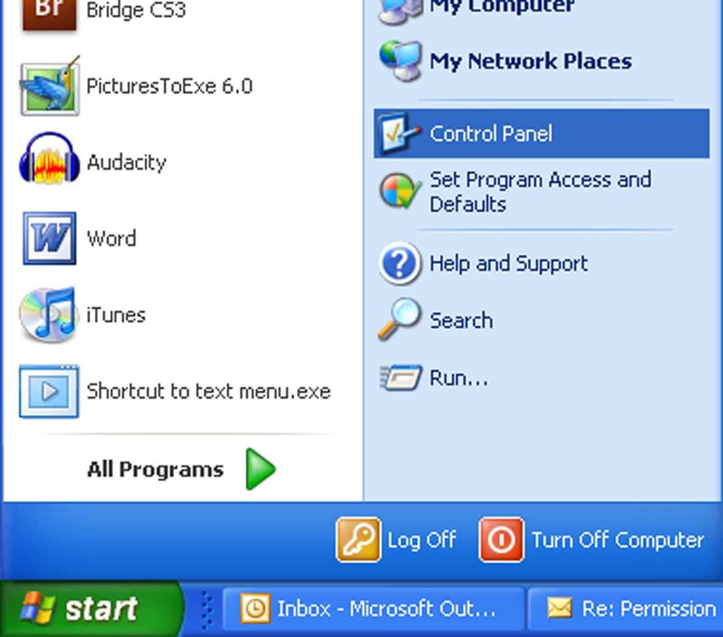
The Control panel may open in  Classic View, as shown alongside.  Find the Fonts option and click | 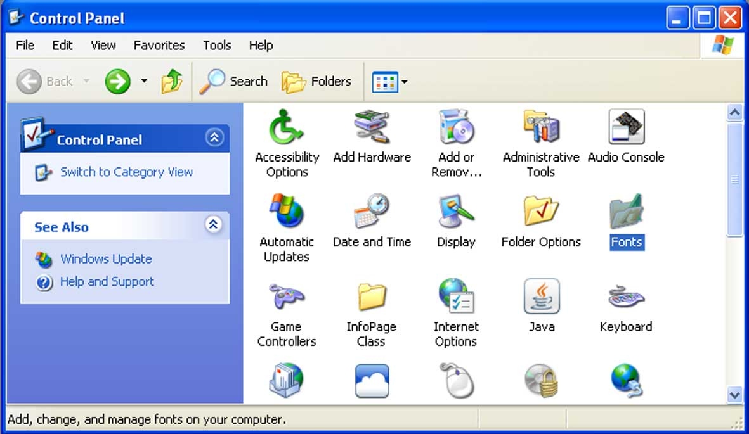
Alternatively, the Control Panel may open in Category view.  Click on ‘Appearance and Themes’  And then, under ‘See also’ click on Fonts | 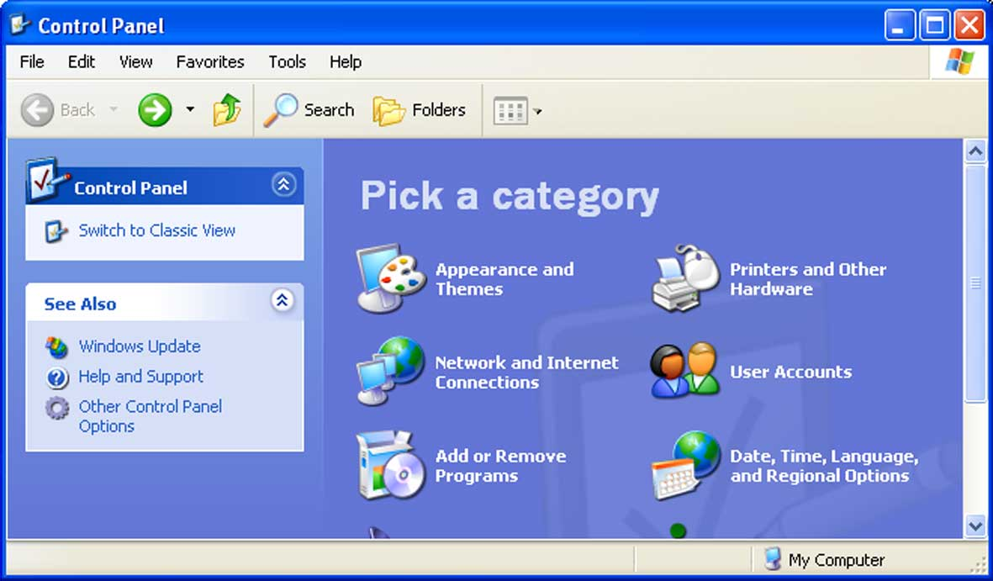  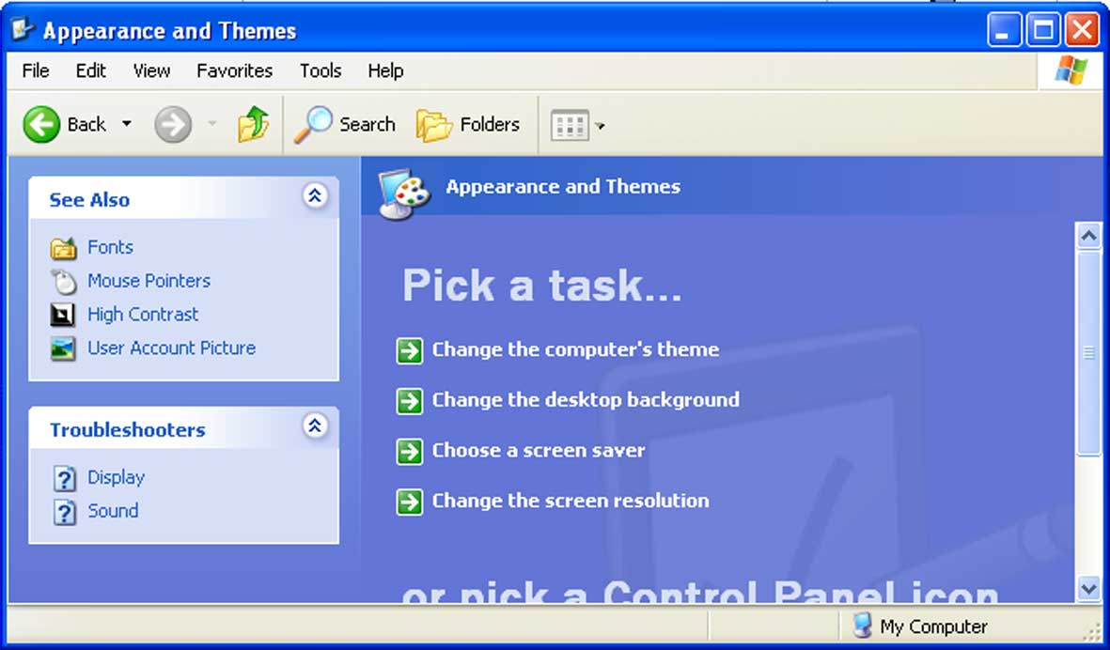
A Fonts folder will open.  Click on File  …and then Install New Font… | 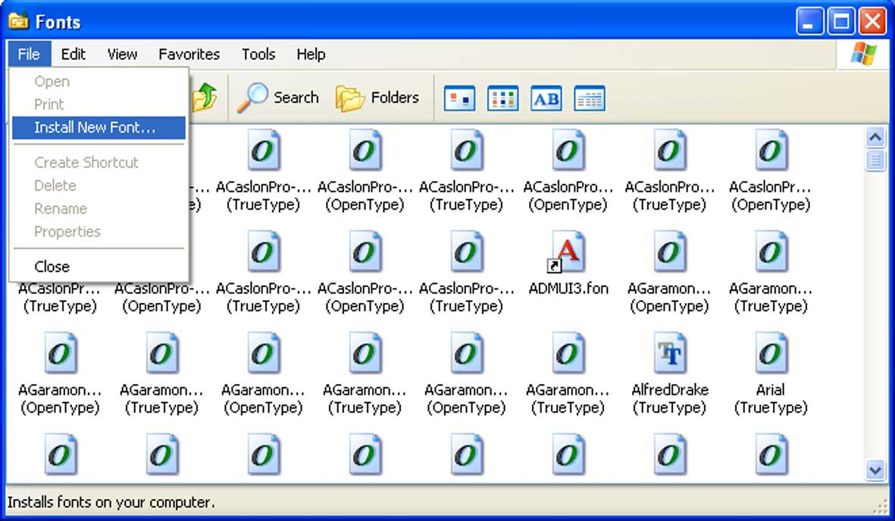  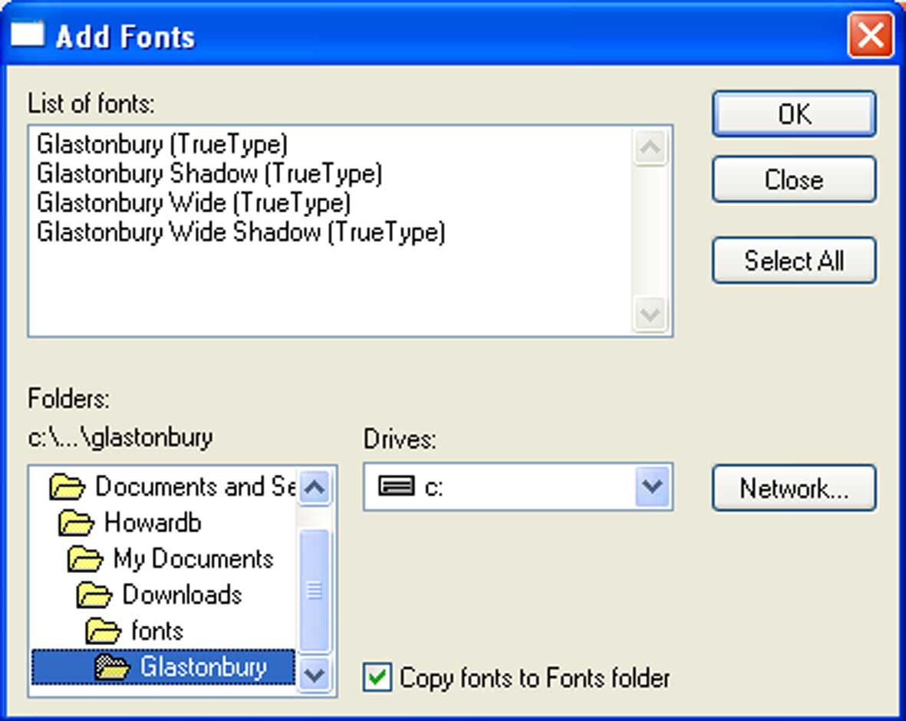
In the dialogue box, navigate to your download folder
…and find the folder containing your new font
Make sure this box is ticked
 | 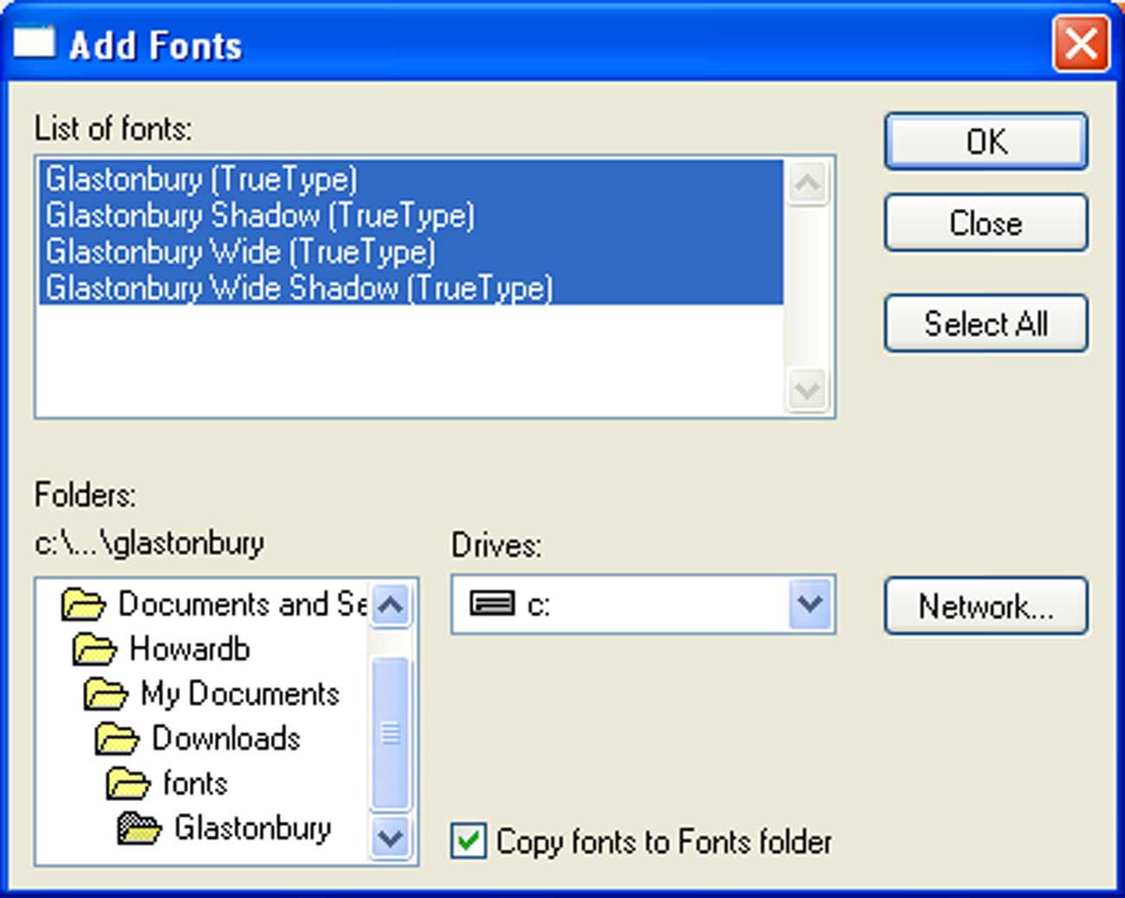
If more than one font is available, chose all of them or make a selection (highlight in blue).

Then click OK
